

**STANDARD OPERATING PROCEDURE**

**Do not Photocopy**

**Document Information Classification: Unrestricted**

|  |  |
| --- | --- |
| **Title:** | **Managing TRE Project Records** |
| **Effective Date:** | **22 Jul 2019** |
| **Reference Number:** | **SOP-03-06** |
| **Version Number:** | **3.0** |
| **Owner:** | **Information Security Manager,** |
| **Review Date:** | **22 Jul 2021** |

Table of Contents

1. Purpose 3

2. Scope 3

3. Responsibilities 3

4. Procedure 3

4.1. The JIRA Project 3

4.2. Accessing JIRA 4

4.3. The JIRA TRE Project Record 4

4.4. Creating the TRE Project Record 5

4.5. Changing Project Record Workflow Status 7

4.6. Adding the Project Record Activities 7

4.7. Viewing Project and Activity Records 8

4.8. Updating Project and Activity Records 10

4.9. Closing or Cancelling a TRE Project Record 11

5. Cross-referenced ISMS Documents 11

6. Appendices 11

1. Purpose

Changes to the systems that affect information security should be controlled including a formal user registration and de-registration process which should be implemented to enable assignment of access rights.

This document provides instructions on how to create and manage JIRA records for TRE Projects.

1. Scope

Any research project that requires access to data that is stored in the TRE.

JIRA only provides administrative information related to TRE projects within the TRE. The JIRA system has no access to, or control over the project and user account administration services within the TRE and these are out of scope of this procedure.

1. Responsibilities

TRE Operations Manager is responsible for:

* Creating the TRE Project records
* Assigning TRE Project Members to TRE Projects

TRE Operations Team members are responsible for

* Maintaining TRE Project records

1. Procedure
   1. The JIRA Project

JIRA is a software tool used for project and issue tracking. The records for storing the administrative information related to TRE projects are held within the CHI JIRA site in a JIRA project named ‘TRE Projects’.



All references to TRE project records throughout the remainder of this document relate to the individual records for each TRE project (e.g. TRE-001, TRE-002).

* 1. Accessing JIRA

The CHI JIRA site can be accessed from the following link:

<https://git.elabdev.org/jira/secure/Dashboard.jspa>

Opening this link will display the JIRA login screen where the login username and password can be entered.

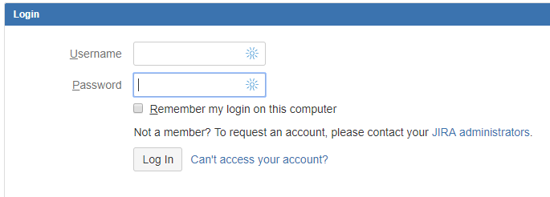

* 1. The JIRA TRE Project Record

The TRE project record in JIRA will be made up of 3 JIRA issue types.

* Project – JIRA Epic
* Project Activities – JIRA Story
* Project Issue – JIRA Task

The Project can be assigned any of the following workflow stages

* Application Form Received
* Application Review in progress
* Application Approved
* Project Live
* Application Rejected
* Project Closed
* Project Cancelled

Activities can be completed as part of the project. These project activities will be as follows:

* Data sharing agreement (Managed projects only)
* Infrastructure setup (Managed and unmanaged projects)
* Data Import (Managed projects only)
* User account creation (Managed and unmanaged projects)
* Users SSH Public key (Managed and unmanaged projects)
* User induction (Managed and unmanaged projects)
* Project Closure (Managed and unmanaged projects)

Each project activity can be assigned one of the following workflow stages

* Open
* In-progress
* Done
* Cancelled

Any issues raised during the project will be created as tasks. These will be managed with the following workflow stages:

* Backlog
* To Do
* Done
* In Progress

The relationship between these items is shown in the diagram below.



* 1. Creating the TRE Project Record

To create a TRE project record in JIRA click on the ‘Create’ option from the JIRA menu bar. This displays the “Create Issue” screen

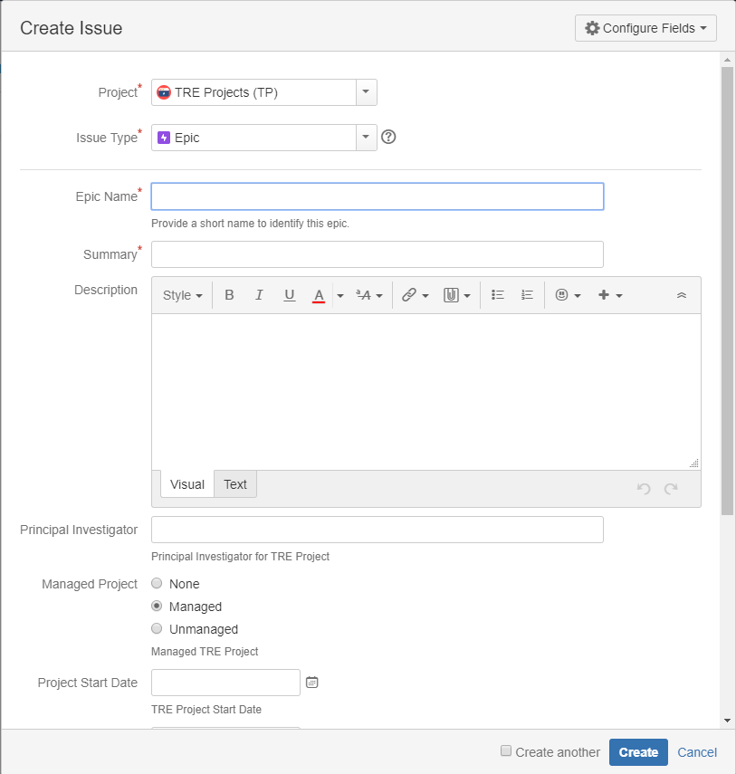

Enter the details for the TRE project as follows:

* **Project ID**: TRE Projects
* **Issue Type** - Epic
* **Epic Name**: The project number e.g. TRE 001. The number must be unique
* **Summary**: The Epic name and the project name e.g. “TRE 001 A TRE Project”
* **Description** – A brief description of the project (it may already be available in the official abstract provided on the application form).
* **Principal Investigator**: Each TRE project must be associated with at least one person, appointed the role of Principal Investigator.
* **Managed Project** – Indicate whether the project is managed or unmanaged
* **Project Start and End dates**: The forecast start and end dates for the project
* **Data Provider -** Details of the owner of the data (if applicable) such as their name, address, and contact phone number.
* **Personally Identifiable Data:** Indicates whether the data to be hosted in the TRE will be identifiable or anonymised.
* **Reporter** – The person creating the project record
* **Assignee** – The person with overall responsibility for managing the record

Click on ‘Create’ to create the project record.

* 1. Changing Project Record Workflow Status

Once the TRE project record has been created the workflow status can be changed as appropriate by clicking on the workflow buttons on the issue screen.

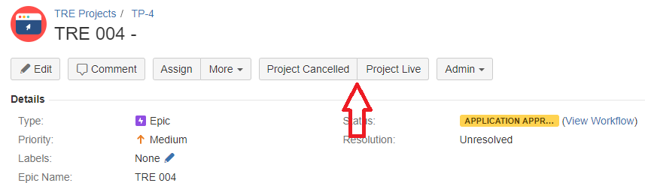

* 1. Adding the Project Record Activities

TRE Project activities should not be added in JIRA until the project application has been approved by the ISSG. This will minimise the number of records in the system should the project be rejected or cancelled at an early stage.

Project activities can be added individually or bulk added as a JIRA administrative activity. Bulk addition of activities will not be defined within this procedure.

To add an individual activity click on the ‘Create’ option from the menu bar. This displays the “Create Issue” screen.

Change the Issue Type field to “Story”

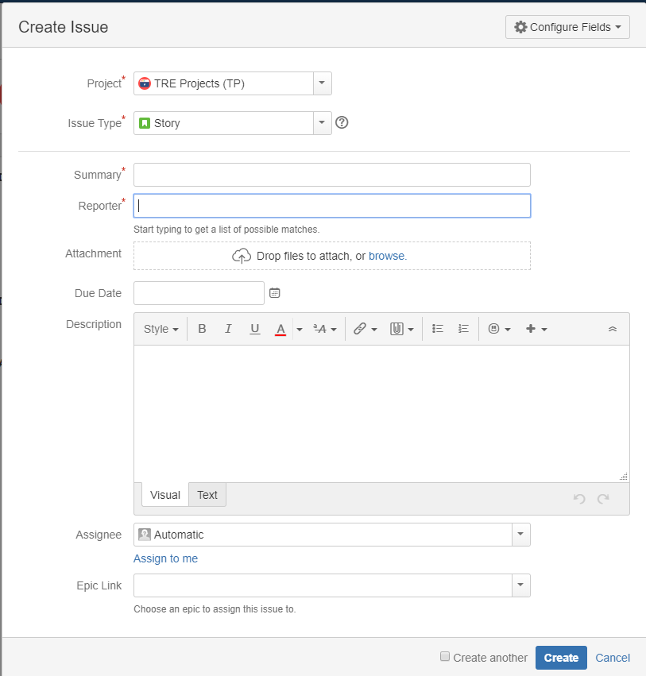

Enter the details for the project activity as follows:

* **Project ID**: TRE Projects
* **Issue Type** - Story
* **Summary**: The Activity Name e.g. “Data Import”. The activity name should only be from the approved list of activities (see section 4.1)
* **Reporter** – The person creating the project record
* **Due Date**: The forecast end dates for the activity
* **Description** – A brief description of the project (it may already be available in the official abstract provided on the application form).
* **Assignee** – The person who will be responsible for managing the activity
* **EPIC Link**: Link to the TRE Project record

Click on ‘Create’ to create the project activity record.

* 1. Viewing Project and Activity Records

To view TRE project records click on the ‘Issues’ option from the menu bar and select the ‘All TRE Projects’ filter option.

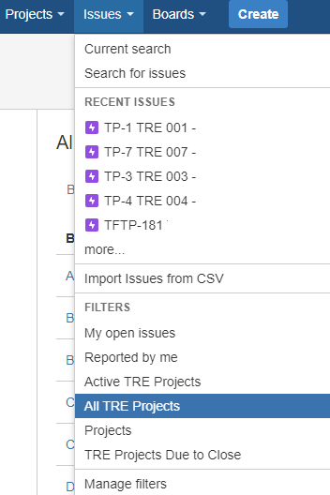

The TRE project records will be listed and an individual project record can be accessed by clicking on the project name (the ‘Active TRE Projects’ filter will display only the active TRE projects i.e. those that are not closed).

This will display the project record and any associated project activities (as ‘Issues in Epic’):

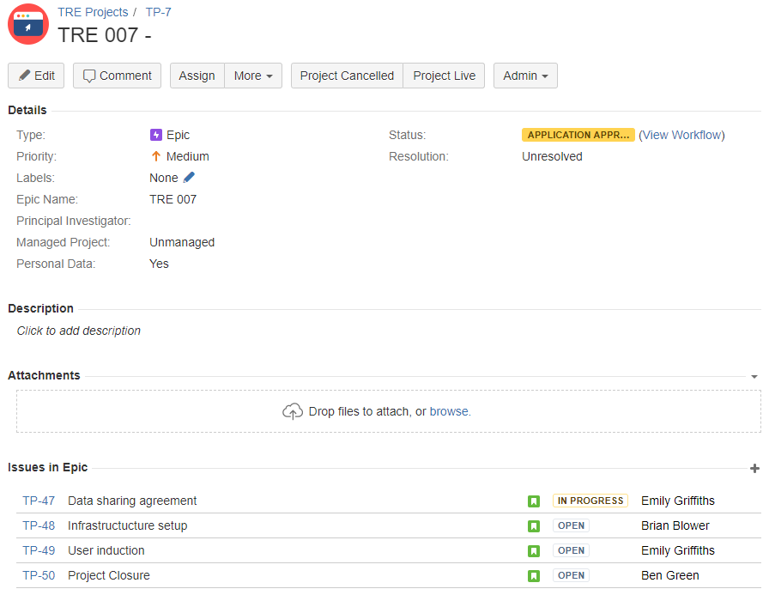

The project activities can be accessed by clicking on the record number.

* 1. Updating Project and Activity Records

When the TRE project record or project activity has been accessed the details can be updated to complete any of the following:

1. Change workflow status e.g. from “In-progress” to “Done”
2. Add an attachment e.g. the Data Sharing Agreement
3. Add comment e.g. explaining change in workflow status

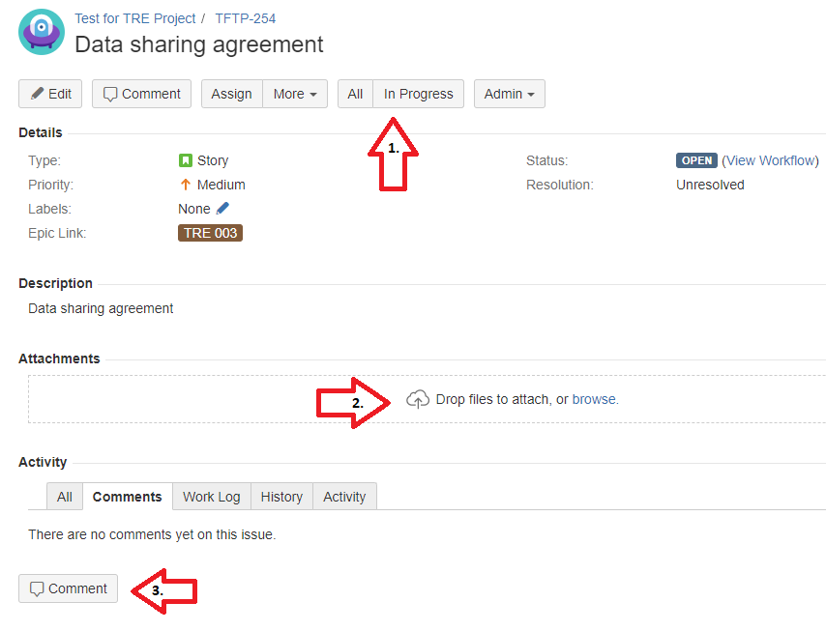

* 1. Closing or Cancelling a TRE Project Record

When a TRE project record is to be closed or cancelled all of the project activities must also be in an equivalent workflow status of ‘Done’ or ‘Cancelled’.

The project status is updated as per the instructions in section 4.4.

The records should never be deleted to ensure that a fully auditable activity record is maintained. This maintains an audit trail of the datasets and legal agreements that were put in place for the project.

1. Cross-referenced ISMS Documents

|  |  |  |
| --- | --- | --- |
| Number | Type | Title |
| FORM-002 | ISMS\Forms | TRE Project Application Form |
| SOP-03-24 | ISMS\SOP\TRE Operations - SOP | Migrating Projects out of the TRE |
| SOP-03-09 | ISMS\SOP\TRE Operations - SOP | TRE Project Application Review |

1. Appendices

None